*Stage IV –* ***Design***

Team 4 (//No Comment): Lindsey, Arielle, Cassandra, Beau, Brittany, & Warren

April 5, 2016

**Design Class Diagram**

AnalysisClass(1).png

**System Sequence Diagrams**

**Use case:** Access Basic Facilities Data

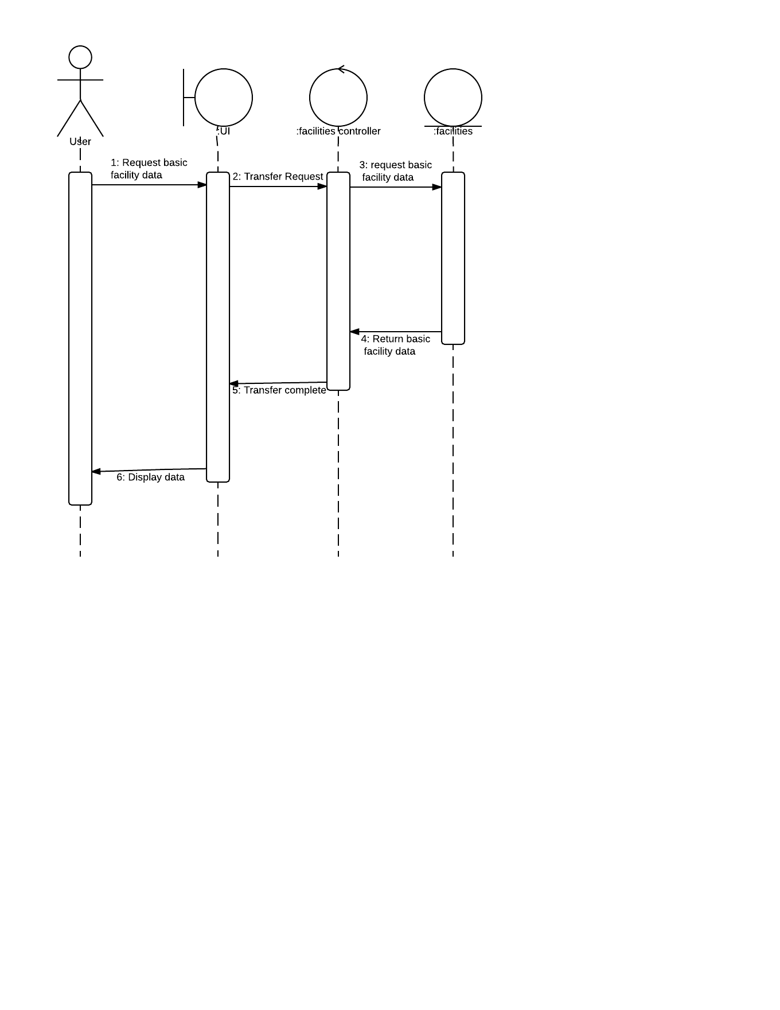

**Use case:** Access Advanced Facilities Data

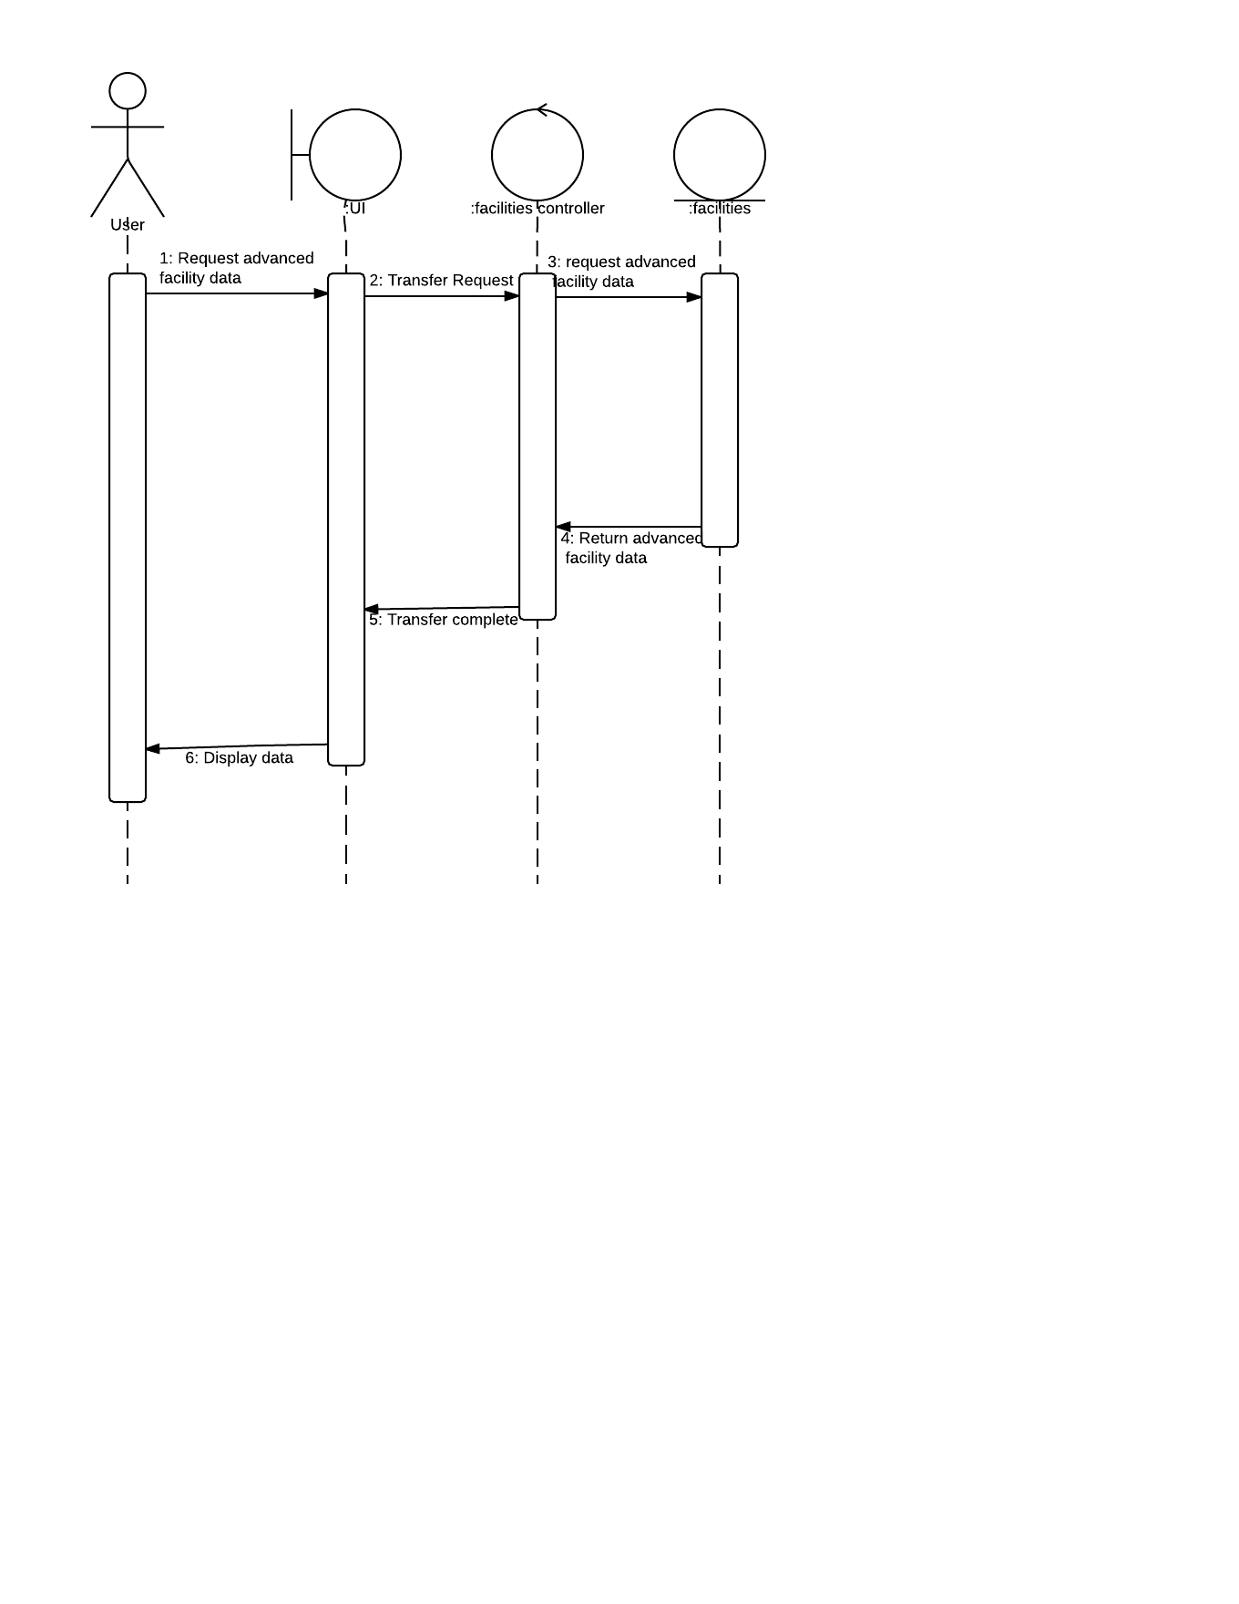

**Use case:** Query Chemical

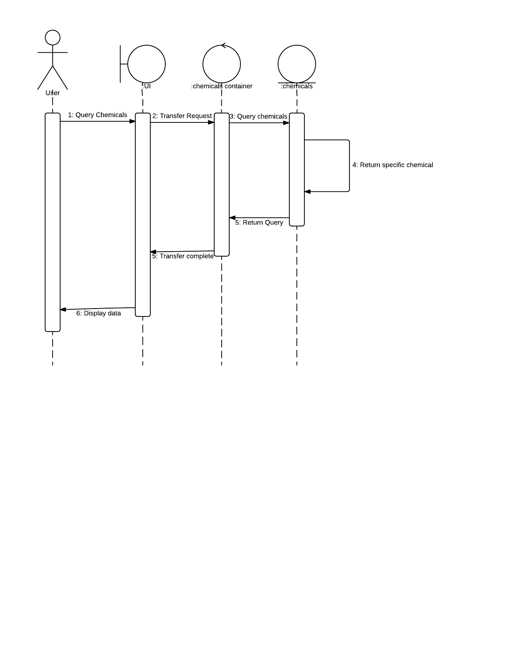

**Use case:** Query facility

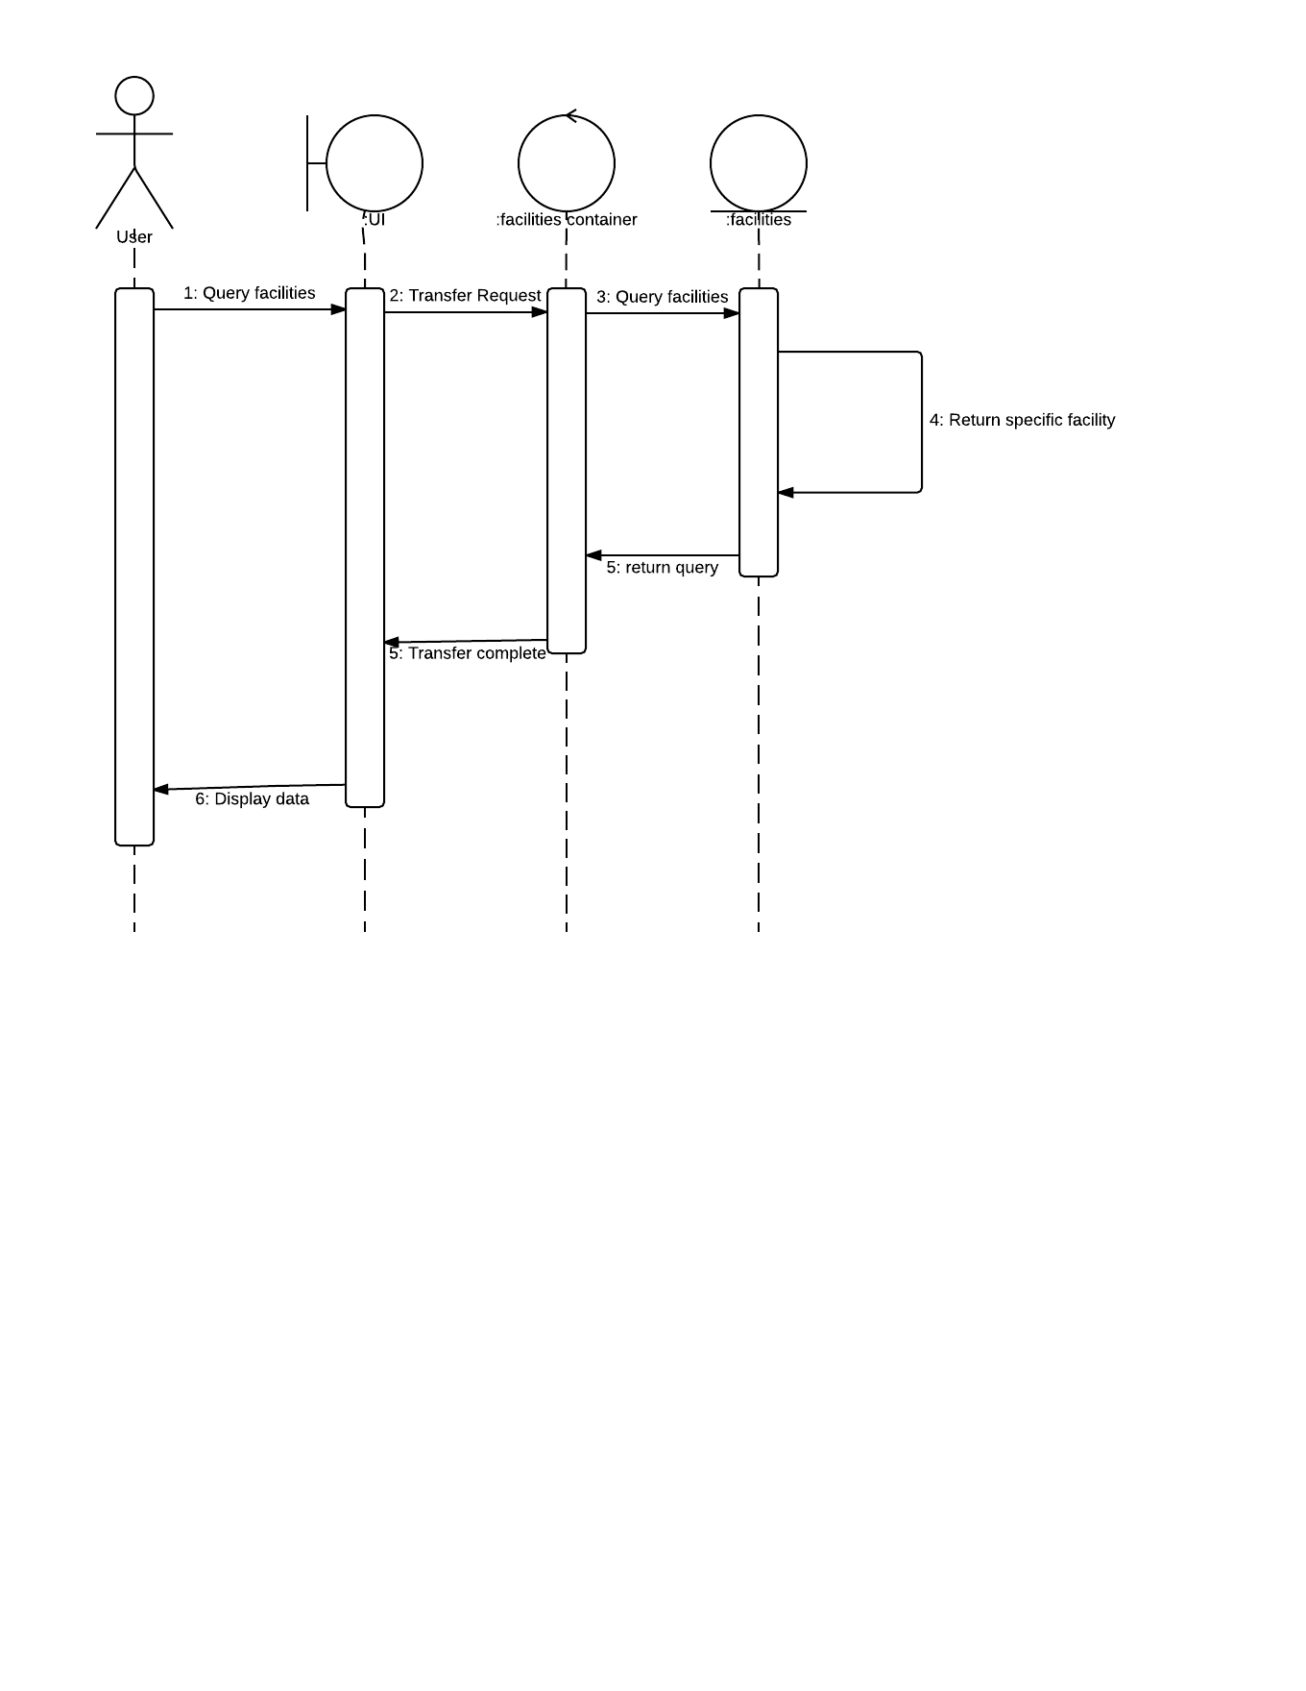

**Use case: Access Advanced Tableview: Chemicals**

Access Advanced Table View Chems.png

**Use case:** Access Tableview: Chemicals

Access Basic Table View Chemicals.png

**Use case:** Get Facilities Pie Chart

Get Facilities Pie Chart (1).png

**State Chart**

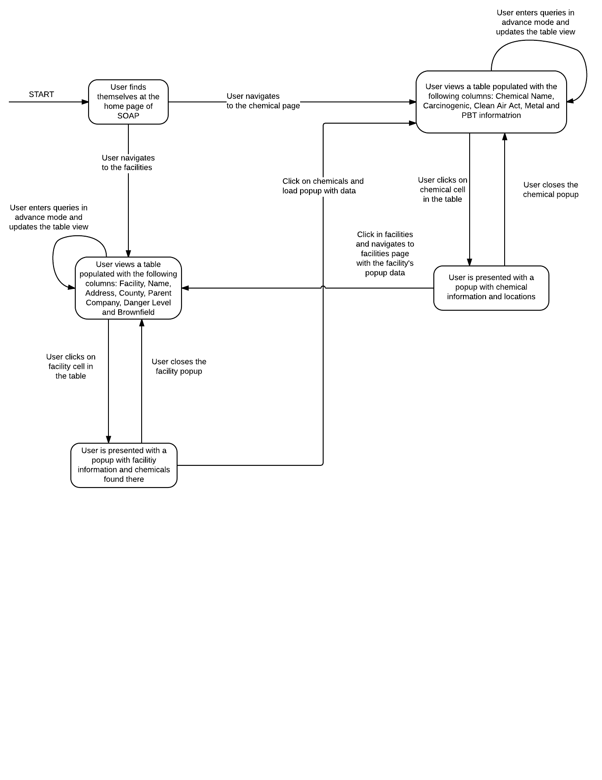

## **User Interface:**

**Facilities Popup (location):**

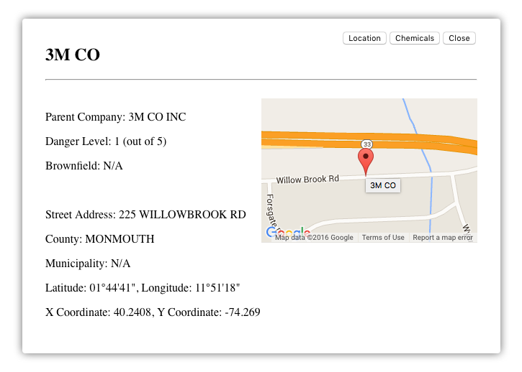

**Facilities Popup (Stats):**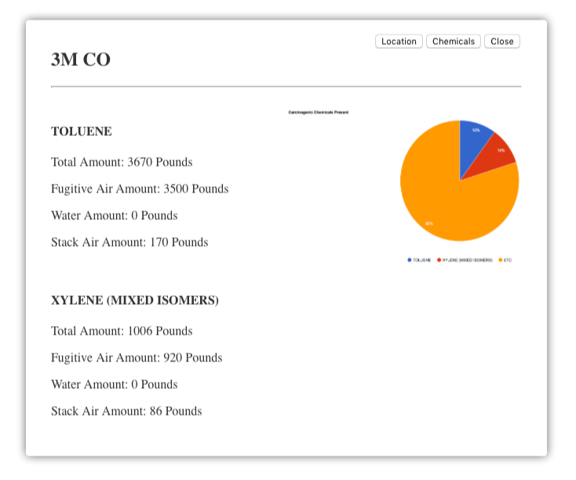

**Chemical Popup (Stats):**

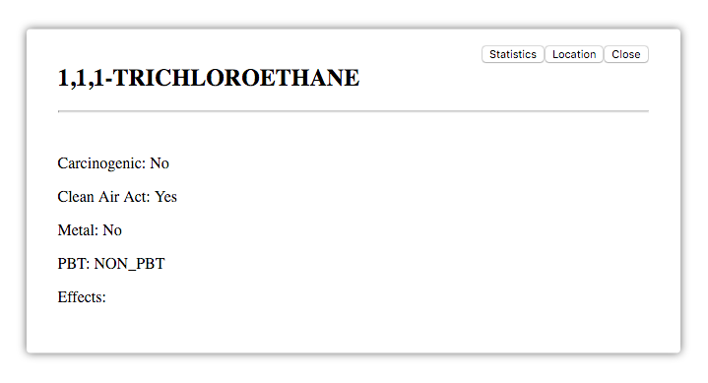

**Chemical Popup (locations):**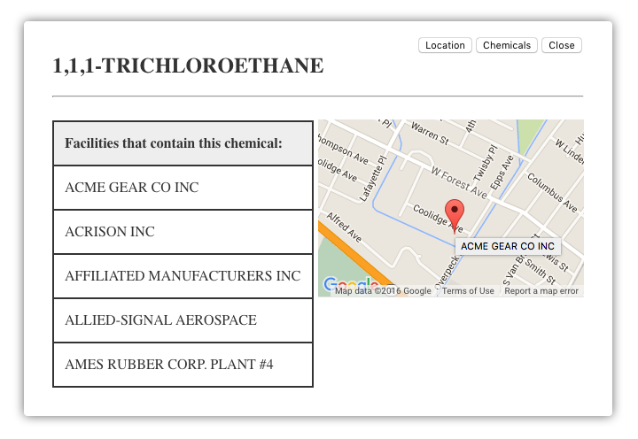

**Eight Golden Rules**

**1. Strive for consistency**

* The UI uses consistent colors with the SOAP website and the same font throughout the design
* The buttons for the UI are in the same places throughout the design
* The text is always placed on the left side of the screen and the corresponding image or graph is placed on the right side

**2. Enable frequent users to use shortcuts**

* The system already allows for shortcuts with its ability for the user to search for facilities or chemicals that they want information about

**3. Offer informative feedback**

* When the user clicks one of the buttons, it will highlight to indicative to the user that their request went through

**4. Design dialog to yield closure**

* Because the user is only requesting to view data with the module being implemented, they are no necessary dialogs needed to yield closure

**5. Offer simple error handling**

* Because the user will not actually be entering information into the system, the only error handling will occur when there is no data when the system is requested to display data. In this case, instead of data being displayed, the screen will state that there is no data to display.
* Also, if there is a problem when connecting to the database server, there will be feedback given to the user saying that the system is trying to connect

**6. Permit easy reversal of actions**

* The design of the user interface does not allow the user to make many mistakes. The only mistake being if they accidentally click a button that launches one of the windows, they have the option to close the window and go back to click the desired option.

**7. Support internal locus of control**

* The user has the capability to customise the information they are presented with by choosing whether to view a basic or advanced view
* The user has the ability to interact with and customise the map that shows the location of the facilities as a result of using google maps

**8. Reduce short-term memory load**

* Because the user is not inputting data, they will not be required to remember information from one screen to the next
* Understanding the structure of the user interface appears intuitive so the user will not have to put much thought into how to navigate the user interface